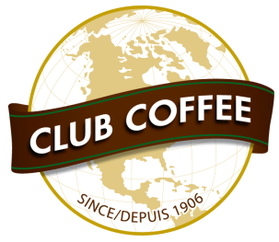

FOR IMMEDIATE RELEASE

World-leading Compostable Coffee Pods Approved for Seattle Food Waste Collection
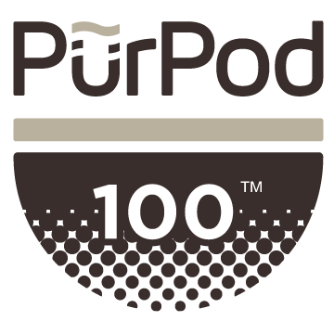
SEATTLE, WA/ TORONTO, ON/VANCOUVER BC – November 28, 2017 – Seattle-area residents can now compost single serve coffee pods in the PurPod100™ format with the rest of their food waste. Composting leader Cedar Grove has approved all coffee pods made using the certified 100% compostable PurPod100™ innovation as the first (and only for now) to be accepted in their residential curbside organics programs serving more than 300,000 households in Seattle and the Pacific Northwest.
The decision includes brands such as Boyd’s, Ethical Bean and Jumping Bean whose cartons are marked with the PürPod100™ logo. This action builds on Seattle’s global reputation for environmental leadership and follows Cedar Grove’s 2016 acceptance of PurPod100™ coffee pods from its commercial and institutional customers. The approval followed extensive testing of the pods and consumer information studies after certification of the pods as compostable by the Biodegradable Products Institute (BPI).
Club Coffee CEO John Pigott applauded the action, “100% compostable pods are the clear choice for people who want quality coffee and single serve convenience without the waste associated with conventional plastic pods. Cedar Grove is a leader in composting and organics recycling and we are glad to earn their support in diverting single serve coffee waste in the Pacific Northwest to composting.” Club Coffee is the producer of PurPod100™ the world’s first certified 100% compostable pod for coffee, tea and other hot beverages.
Cedar Grove’s Director of Marketing and Community Relations Karen Dawson stressed that only brands in this certified 100% compostable format are being accepted. “Other brands claim to be compostable or biodegradable but it’s very simple – until they meet our testing requirements as truly 100% compostable, they don’t work in our program.” Cedar Grove lists items it accepts including the 100% compostable pods at http://cedar-grove.com/compostable/accepted-items.
Cedar Grove approved the pods for inclusion after multiple tests and because the pod’s brown ring and PurPod100™ information are key distinguishing features, helping consumers identify that these pods can go in the organics waste stream. The pods were tracked to ensure they broke down fully to become part of the compost that the company sells to customers. Other tests in Seattle-area condo and apartment buildings and in offices such as at the University of Washington showed that people will dispose properly of approved compostable pods.
Testing processes at Cedar Grove are facilitated by the Compost Manufacturing Alliance. “The Compost Manufacturing Alliance, acting as the field testing agent for Cedar Grove and nineteen other processing facilities in the U.S., commends Club Coffee’s ongoing efforts to proactively engage compost manufacturers in their efforts,” said Susan Thoman, Principal and Managing Director.
The decision comes as the Ontario legislature in Canada debates a bill that would require all single serve pods to be compostable. If approved, Toronto would be the first major city in the world to switch completely to compostable coffee pods, a move seen by many waste management experts as a progressive act towards single serve waste reduction. Further testing is expected to lead to other composters accepting these pods across the country following Seattle’s lead.
-30-

About Club Coffee – www.clubcoffee.ca
Since 1906, Club Coffee has built a reputation for quality and innovation. With more than 500 custom label products and more than 160 Club Coffee branded products, we are the largest roaster, contract manufacturer and distributor of packaged coffees that Canadians buy from grocery stores. Club Coffee fully meets the stringent requirements for Organic, Rainforest Alliance, Fair Trade and Kosher certifications, and is a leader in developing sustainable coffee solutions.
Learn more about PurPod100™, the world’s first Certified 100% Compostable single serve pod for coffee, tea and other hot beverages in the dominant North American single serve format at www.purpod100.com
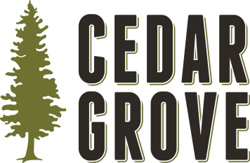
About Cedar Grove – www.cedar-grove.com
Cedar Grove Composting is a local, family-owned business with deep roots in the Seattle area dating back to 1938. Cedar Grove plays a critical role in the Puget Sound’s recycling infrastructure and sustainability efforts, diverting more than 350,000 tons of yard waste and food scraps from landfills annually. With two processing facilities in Maple Valley and Everett, Cedar Grove is a local manufacturer providing green jobs in King and Snohomish Counties. Cedar Grove produces wholesome, nutrient-rich compost that is sold to businesses, governments and residents, ensuring consumers have access to locally produced, recycled products. For more information, please visit www.cedar-grove.com or follow Cedar Grove on Facebook, Twitter or Instagram.

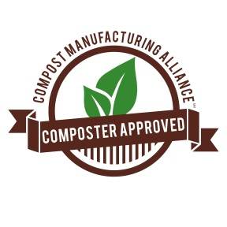
About the Compost Manufacturing Alliance – www.composterapproved.com
The Compost Manufacturing Alliance is a partnership of pioneering composters throughout the U.S. developing competent and reliable field validation of feed stocks within emerging and real-world processing technologies. Learn more by visiting www.composterapproved.com
About the Biodegradable Products Institute – www.bpiworld.org
The Biodegradable Products Institute (BPI) is a not-for-profit organization that educates, advocates, and certifies materials as compostable in large-scale composting facilities. All certified products and materials must meet ASTM D6400 or D6868 test requirements, as performed in a BPI-approved laboratory, whose results are then certified by an independent third party. The BPI is the largest certification organization for compostable products in North America and its Compostable Logo is recognized by composters and manufacturers across the continent. For an authoritative list of certified compostable products, please visit: products.bpiworld.org.
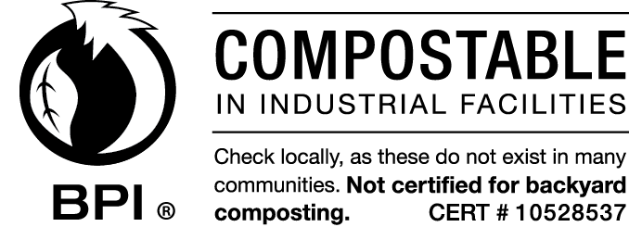

For media requests or further information, please contact:
Solange Ackrill
416-675-1300
sackrill@clubcoffee.ca

